Exercices son [tion]

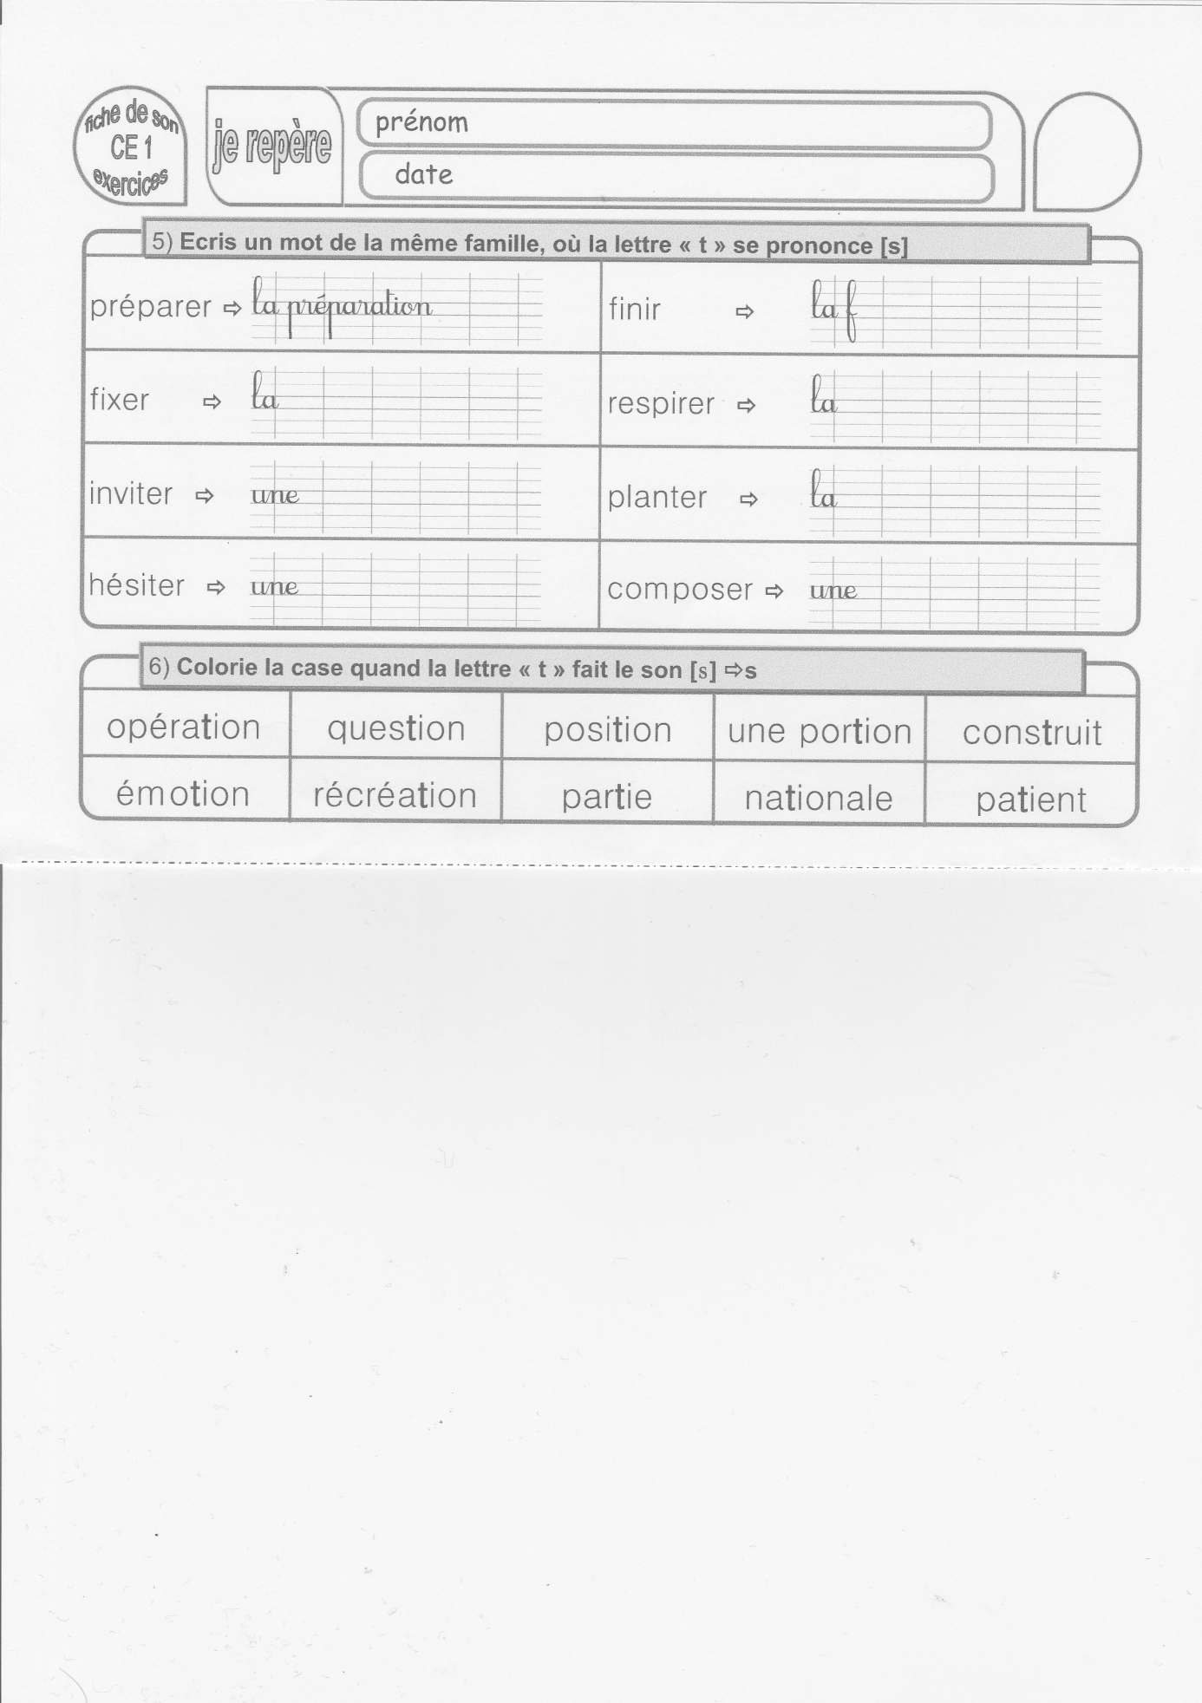

composition

plantation

respiration

finition

hésitation

invitation

fixation