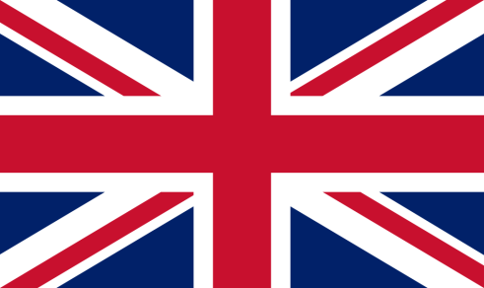Anglais

Hello !

**Entoure la bonne réponse**

How are you ?



⮱I’m

fine happy sad so-so angry

What’s the day today ?

⮱Today is Monday Tuesday Wednesday Thursday Friday Saturday Sunday

What’s the weather like ?

C:\Program Files (x86)\Microsoft Office\MEDIA\CAGCAT10\j0293828.wmf

It’s

sunny raining cloudy windy

The colors

**Colorie de la bonne couleur**

|  |  |  |  |
| --- | --- | --- | --- |
|  | RED |  | BROWN |
|  | BLUE |  | BLACK |
|  | YELLOW |  | WHITE |
|  | GREEN |  | GREY |
|  | ORANGE |  | PINK |
|  | PURPLE |